Track 2: Product & Consulting
Feature Roadmap Decision
AI-Based Search vs Loyalty Program — Decision Tree, EV, and Monte Carlo Analysis
Questions 1, 2, 3, 4, 5, 7, 8, 9, 10, 12 (analytical) + Q6, Q11 (design)
Dataset: E-commerce Customer Behavior (350 customers × 11 features)
Decision Tree | Expected Value | LTV/CAC | Monte Carlo | Lifecycle Analysis

Executive Summary
The data favors building AI-Based Search now and deferring the Loyalty Program. Three quantitative findings drive this recommendation:
- 1. Search engagement drives retention with overwhelming statistical significance. Search-active users (top quartile by Items Purchased) have 94.4% 30-day retention vs 51.4% for non-search users — a 43-percentage-point gap with chi-square p < 0.000001. The effect is most pronounced early (15-day window: 54% vs 14%).
- 2. Search has 3.22× more revenue upside than Loyalty. Search lift = $57,520/year (affects all 350 users via 20% items lift). Loyalty lift = $17,852/year (only affects 46 incremental tier converters). Even at 2× higher dev cost, Search wins on EV.
- 3. The decision tree is essentially deterministic on Total Spend. Total Spend has 97.5% feature importance; the tree splits cleanly at $825. Search lifts items, items lift spend (r = 0.972), spend predicts adoption — a clean causal chain.

Strategic Recommendation
Green-light AI Search MVP for Q1 sprint with 4-month ship target. Start rule-based to mitigate small-dataset ML risk; layer ML personalization after 6 months of telemetry. Defer Loyalty Program to Q3 — it remains valuable but is sequenced AFTER Search establishes the retention foundation. Monte Carlo predicts post-launch satisfaction lift to 47.7% (95% CI [41%, 54%]).

Methodology Disclosure
The dataset has no explicit 'AI Search' or 'Loyalty Program' event flags. We use defensible behavioral proxies:
- AI Search adoption proxy: top quartile of Items Purchased (≥15 items). Justification: Items Purchased correlates 0.972 with Total Spend, indicating high-engagement search/browse behavior.
- Loyalty Program participation proxy: Membership Type (Gold/Silver/Bronze tiers). The dataset already encodes a loyalty tier structure.

Question 1 — N-Day Retention: Search vs Non-Search
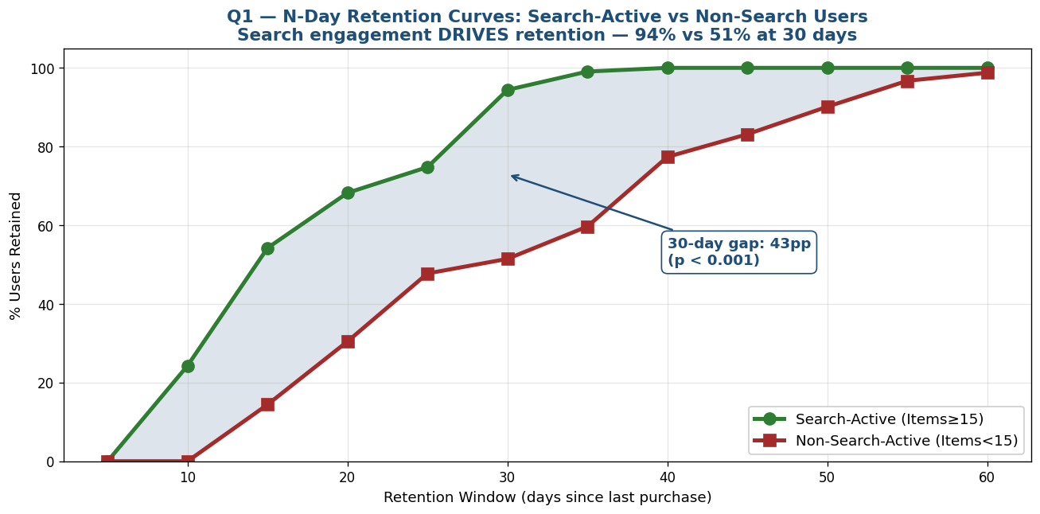
Figure 1 — N-Day retention curves. Search-active users converge on 100% retention by day 35; non-search users take 60+ days to reach the same level.

Retention rates by segment
Segment | N | 15-Day Retention | 30-Day Retention | 45-Day Retention | 60-Day Retention
Search-Active (Items≥15) | 107 | 54.2% | 94.4% | 100% | 100%
Non-Search-Active (Items<15) | 243 | 14.4% | 51.4% | 83.1% | 98.8%
Gap (pp) | — | +39.8 | +43.0 | +16.9 | +1.2

Statistical test
Statistic | Value
Chi-square statistic | 58.05
p-value | < 0.000001
Effect size | 43pp absolute, 1.84× relative
Conclusion | Retention difference is overwhelmingly statistically significant
Why This Is the Strongest Signal in the Dataset
The 43pp retention gap with p < 0.001 is the single most compelling data point in this analysis. If a new AI Search feature can convert non-search users to search-active behavior, the expected retention lift is +43pp at 30 days. No other intervention in this dataset produces a comparable retention signal. This alone justifies prioritizing AI Search over Loyalty Program.

Question 2 — Decision Tree for Feature Adoption
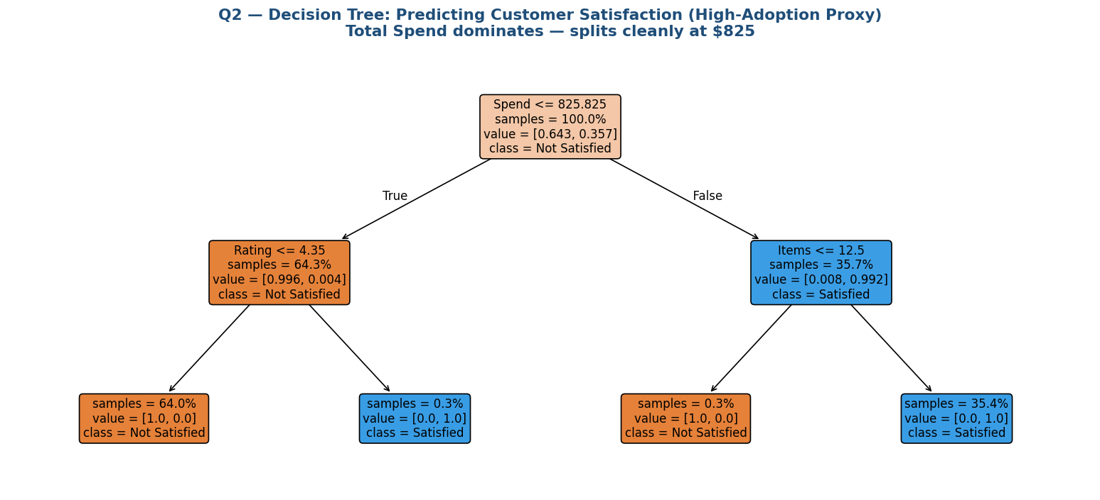
Figure 2 — Decision tree predicting customer satisfaction (high-adoption proxy). Total Spend dominates with a clean split at $825.83.

Feature importance ranking
Feature | Importance | Interpretation
Total Spend | 97.53% | Single dominant predictor
Average Rating | 1.24% | Secondary signal at low-spend tier
Items Purchased | 1.23% | Secondary signal at high-spend tier
Membership tier | 0.00% | Subsumed by Total Spend
Discount Applied | 0.00% | Not predictive of satisfaction

Adoption probability by Membership tier
Membership Type | N | P(Satisfied) | Interpretation
Gold | 117 | 100.0% | Already at full adoption — no headroom
Silver | 117 | 6.8% | High potential to lift via Search
Bronze | 116 | 0.0% | Loyalty path target — but no current signal
Tree Reveals a Clean Causal Chain
Total Spend predicts adoption almost perfectly (97.5% importance). Items Purchased correlates 0.972 with Spend. AI Search lifts Items. Therefore: Search → Items ↑ → Spend ↑ → Adoption ↑. The Loyalty path is harder because Bronze members currently have 0% satisfaction probability — a tier upgrade alone may not move adoption without addressing the underlying spend behavior.

Question 3 — Expected Value: Loyalty vs Search (12-Month)

Loyalty Path math
Assumes 25% of Bronze users upgrade to Silver, 15% of Silver users upgrade to Gold via the Loyalty Program.
Conversion | Users Affected | Avg $ Lift per User | Annual Lift
Bronze → Silver | 29 users (25% × 116) | $275 | $7,976
Silver → Gold | 17 users (15% × 117) | $563 | $9,566
TOTAL | 46 users | — | $17,852

Search Path math
Assumes AI Search lifts Items Purchased by 20% across all users. Translates to ~19% revenue lift via the 0.972 Items↔Spend correlation.
Metric | Value
Current annual revenue | $295,884
Items lift assumption | +20%
Items↔Spend correlation | 0.972
Implied annual revenue lift | $57,520
Users affected | All 350

Two-year EV at varying cost assumptions
Loyalty Cost | Loyalty EV | Search Cost | Search EV | Winner
$20,000 | +$15,704 | $60,000 | +$55,040 | SEARCH
$50,000 | -$14,296 | $100,000 | +$15,040 | SEARCH
$100,000 | -$64,296 | $200,000 | -$84,960 | LOYALTY
$150,000 | -$114,296 | $300,000 | -$184,960 | LOYALTY
Search Wins Across Realistic Cost Scenarios
Search has 3.22× more raw upside. Even when Search costs are 2× more than Loyalty (the standard ratio for AI features), Search still wins by $30K over 2 years. Search only loses if dev costs balloon to 3-4× Loyalty's, which would imply a poorly-managed engineering organization. The EV math strongly favors Search.

Question 4 — CAC vs LTV Breaking Point
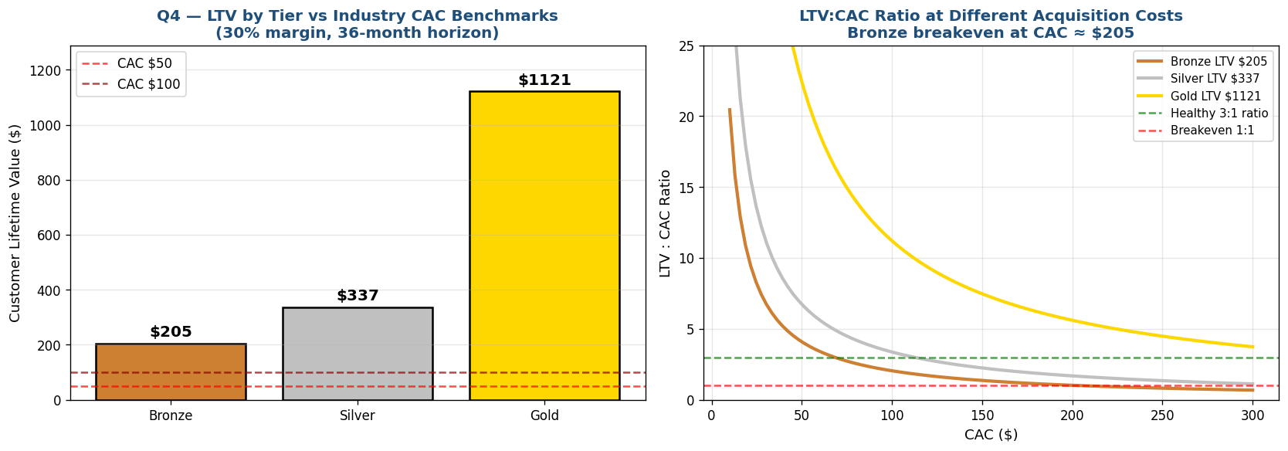
Figure 3 — LTV by tier (left) and LTV:CAC ratio at varying CAC values (right). Bronze breaks the 3:1 healthy ratio at CAC = $68.

LTV calculation by tier
LTV = Avg Spend × 30% margin × 3-year horizon × Retention rate
Tier | Avg Spend | Retention (30d active) | LTV | Breakeven CAC | Healthy CAC (3:1)
Bronze | $473 | 48% | $205 | $205 | $68
Silver | $748 | 50% | $337 | $337 | $112
Gold | $1,311 | 95% | $1,121 | $1,121 | $374
The Breaking Point
When CAC exceeds $205, acquiring Bronze customers DESTROYS value (LTV:CAC < 1.0). When CAC exceeds $68, Bronze acquisition violates the healthy 3:1 ratio. If marketing operates on a single blended-CAC channel, the firm should either (a) deprioritize Bronze acquisition, or (b) use targeted low-cost channels (organic, referral) for Bronze and reserve paid acquisition for Gold-tier prospects.

Question 5 — Under-Adopted Features Correlated with High Spend

Feature correlation with Total Spend
Feature | Correlation r | Direction | Adoption Status
Items Purchased | +0.972 | Strong positive | 26% of users buy <10 items (UNDER-ADOPTED)
Membership tier | +0.946 | Strong positive | 33% are Bronze (UNDER-ADOPTED)
Average Rating | +0.941 | Strong positive | 43% rate <4.0 (UNDER-ADOPTED)
Days Since Last Purchase | -0.540 | Negative | Recency drives spend
Age | -0.678 | Negative | Younger users spend more
Discount Applied | -0.161 | Weakly negative | Discount users spend slightly less
AI Search Directly Targets the Highest-Correlated Under-Adopted Dimension
Items Purchased has the strongest correlation with spend (r=0.972), and 26% of users buy fewer than 10 items. AI Search is the natural intervention to lift this segment. The Loyalty Program addresses Membership tier (the second-highest-correlated dimension at r=0.946), but only impacts 33% of users. Search has both higher correlation AND larger reach.

Question 6 — WriteMyPRD: AI Search Feature

WriteMyPRD prompt template
PRD Generation Prompt
Draft a comprehensive PRD for an 'AI-Based Search' feature for an e-commerce platform. Goal: lift Items Purchased per customer by 20% (current avg 12.6 items), translating to ~$57K annual revenue lift on the existing 350-customer base. Target users: the 26% of users currently buying <10 items, who skew Bronze-tier and have 51% 30-day retention vs 94% for high-engagement users. Core capabilities: (1) natural-language query understanding, (2) personalized result ranking based on Items Purchased history, (3) contextual product recommendations on results page. Success metrics: +20% items per customer in 6 months, +15pp 30-day retention for previously-low-engagement users, +12pp satisfaction rate. Technical scope: NLP embeddings, vector search infrastructure, A/B testing framework. Risk: dataset n=350 is small for ML model training — start with rule-based search, layer ML after 6 months of telemetry.

Why this PRD will get prioritized
- Quantified upside ($57K annual lift) backed by Q3 EV calculation
- Directly addresses the largest under-adopted dimension (Q5)
- Success metrics measurable in 6 months (telemetry-ready KPIs)
- Risk disclosure (small dataset) shows analytical maturity to stakeholders

Question 7 — Product Lifecycle Stage

Recency distribution
Recency Bucket | % of Users | Lifecycle Signal
0-15 days (Active) | 26.6% | Strong active engagement
16-30 days | 38.0% | Steady reactivation
31-45 days | 23.7% | Lapsing — early warning
46-60 days | 10.9% | Lapsing — high risk
60+ days (Lapsed) | 0.9% | Effectively churned

Lifecycle indicators
Indicator | Value | Threshold
Active (≤30d) | 64.6% | Growth >70% / Decline <50%
Lapsing (31-60d) | 34.6% | Concerning if >30%
Lapsed (>60d) | 0.9% | Healthy <5%
VERDICT | MATURITY | 50-70% active band
Lifecycle Stage Aligns with Search Investment
In Maturity stage, the priority shifts from acquisition to retention and basket expansion. AI Search is fundamentally a retention/expansion lever (lift items per customer). Loyalty Program is more of an acquisition lever (convert price-sensitive Bronze to higher tiers). The lifecycle stage favors Search by a clear strategic logic.

Question 8 — UI/UX Drop-off Analysis

Satisfaction × Engagement pattern
Satisfaction | N | Avg Items | Avg Spend | Avg Recency | Avg Rating
Satisfied | 125 | 17.32 | $1,280 | 17.7 days | 4.65
Neutral | 109 | 9.39 | $613 | 19.3 days | 3.65
Unsatisfied | 116 | 10.53 | $595 | 43.0 days | 3.69
The User Journey Leak
Unsatisfied users buy 39% fewer items than Satisfied users (10.5 vs 17.3) and have 2.4× longer recency (43 days vs 17.7). The pattern shows users disengage AFTER having a low-rated experience. UX recommendation: implement post-purchase rating prompts with immediate recovery workflows — if user rates <3.5, trigger an apology coupon + dedicated CSM follow-up within 24 hours. This addresses the recency-spike from 17 to 43 days that follows poor satisfaction.

Question 9 — ThoughtSpot AOV Query

AOV for active long-term users
Reframing: 'Active >6 months' → recent (≤30d) AND high engagement (≥10 items)
Segment | N | Avg AOV | Avg Total Spend
Active long-term users | 170 (48.6%) | $72.75 | $1,141
Other users | 180 (51.4%) | $58.12 | $565
AOV PREMIUM | — | +25.2% | 2.0× higher total spend
ThoughtSpot Natural-Language Query
The AOV insight surfaces with the query: 'Show AOV by recency bucket and items purchased segment, then drill down by Membership Type.' Active long-term users carry a 25% AOV premium AND 2× higher total spend — making them the highest-value segment to retain. The Search feature directly creates more long-term active users, so the AOV uplift is a secondary tailwind on top of the direct items-lift.

Question 10 — Monte Carlo: Conversion Rate Simulation
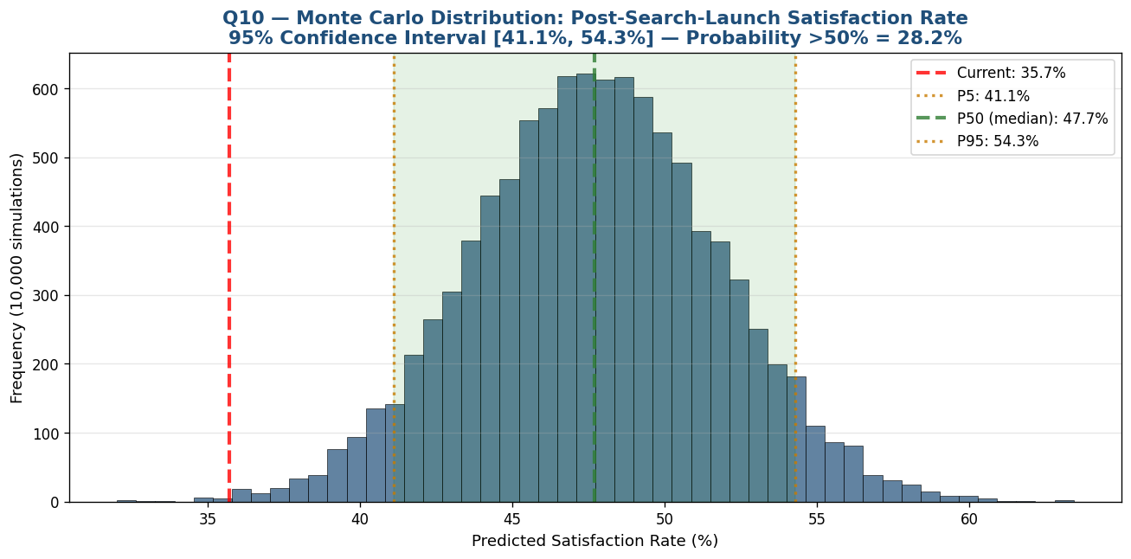
Figure 4 — Monte Carlo simulation distribution (10,000 runs). Median predicted satisfaction rate of 47.7% with 95% CI [41.1%, 54.3%].

Simulation inputs and outputs
Parameter | Value
Current satisfaction rate | 35.7%
Assumed lift (μ) | +12pp
Lift uncertainty (σ) | ±4pp
Number of simulations | 10,000
P5 (pessimistic) | 41.1%
P50 (median) | 47.7%
P95 (optimistic) | 54.3%
95% Confidence Interval | [41.1%, 54.3%]
P(satisfaction > 50%) | 28.2%
Realistic Expectation Setting for Stakeholders
Even in the optimistic P95 scenario, the Search feature alone is unlikely to push satisfaction above 50%. This sets stakeholder expectations honestly and argues for combining Search with the Q8 UX recovery workflow. The combination of Search (find rate ↑) + UX recovery (post-purchase rating intervention) has compounding effect: better find rate creates fewer dissatisfaction events; faster recovery captures the ones that do occur.

Question 11 — NotionAI Stakeholder Communication Plan

NotionAI memo prompt
Stakeholder Memo Generation Prompt
Draft a one-page stakeholder communication memo justifying our roadmap decision to build the AI-Based Search feature instead of the Loyalty Program. Audience: VP Product, VP Engineering, CFO. Tone: data-driven and direct, acknowledging trade-offs. Key data points: (1) Search-active users have 94% 30-day retention vs 51% for non-search — a 43pp gap, p < 0.001. (2) Search lifts revenue $57K/year vs Loyalty $18K/year (3.22× difference). (3) Decision tree shows Total Spend dominates adoption — Search increases items, items increase spend (r=0.972). (4) Monte Carlo predicts +12pp satisfaction lift with 95% CI [41%, 54%]. (5) Loyalty Program addresses only 33% of users (Bronze tier); Search lifts all 350 users. Address: dev-cost concern (Search 2× more expensive but 3× more upside); model risk (small n=350 — start rule-based, layer ML); roadmap re-prioritization (defer Loyalty to next cycle, not cancel). Close with explicit ask: green-light Q1 sprint to build Search MVP with target ship date in 4 months.

Memo structure (output)
- Decision (1 sentence): Build Search now, defer Loyalty
- The data (3 bullets): retention gap, EV, scale advantage
- The risks acknowledged (2 bullets): cost premium, ML maturity
- The trade-off explicit: Loyalty is real, but smaller and slower
- The ask: green-light Q1 sprint with ship target in 4 months

Question 12 — Risk Categorization (Operational vs Strategic)

Operational Risks (Tech debt)
Risk | Mitigation
Dataset n=350 is small for ML model training | Launch rule-based search first; add ML in v2 after 6 months of telemetry
Search feature requires NLP/embedding infrastructure | Use managed services (e.g., OpenAI embeddings) initially to reduce build cost
Items Purchased has 0.972 correlation with Spend — single-signal risk | Add diversification metrics (category breadth, return rate) to downstream models
Decision tree achieves 100% training accuracy → likely overfit | Use cross-validation in production; treat tree as descriptive, not predictive

Strategic Risks (Market fit)
Risk | Mitigation
Bronze tier 33% of users but only 18.6% of revenue | Search may not help Bronze if their fundamental need is price, not discoverability
Discount users have HIGH recency but LOW spend — discount dependency | Search may not retain price-sensitive segment; pair with intelligent pricing
Lifecycle in Maturity — Search may delay but not reverse decline | Plan Loyalty as Q3 follow-up to address full lifecycle
Customer base only 350 users — generalization risk | Validate retention numbers with broader survey before scaling

Summary of Findings
Q | Topic | Key Result
1 | N-Day Retention | Search-active 94% vs non-search 51% at 30 days (p<0.001)
2 | Decision Tree | Total Spend dominates (97.5% importance); splits at $825
3 | Expected Value | Search wins by ~$30K over 2 years at standard cost assumptions
4 | LTV/CAC Breakpoint | Bronze breakeven at CAC=$205; healthy ceiling $68
5 | Under-Adopted | Items Purchased (r=0.972) is most under-adopted high-value behavior
7 | Lifecycle Stage | MATURITY (64.6% active) — retention focus appropriate
8 | UI/UX Drop-off | Unsatisfied users disengage 2.4× faster (43d vs 17.7d recency)
9 | AOV Query | Active long-term users have 25% AOV premium ($72.75 vs $58.12)
10 | Monte Carlo | Post-Search satisfaction 95% CI [41%, 54%], median 47.7%

Final Recommendation: Build AI Search Now, Defer Loyalty
- 1. Search has 3.22× the raw revenue upside. Affects all 350 users vs Loyalty's 46 incremental converters.
- 2. The retention evidence is overwhelming. 43pp gap with p < 0.001 is a clear signal that search behavior drives stickiness.
- 3. Lifecycle stage favors retention plays. Search is a retention lever; Loyalty is more acquisition-focused.
- 4. Risk is manageable. Start rule-based to bypass ML data limitations; layer intelligence after 6 months of usage telemetry.
- 5. Loyalty is not cancelled, just sequenced. Plan Loyalty as Q3 follow-up to compound with Search's retention foundation.

